# Operational Concept Description (OCD)

**Yanomamo Interactive DVD/Online**

**Team No. 6**

**Reetika Rastogi - Project Manager, Life Cycle Planner**

**Rohit Mani - Requirements Engineer, Life Cycle Planner**

**Sanjay Kutty - Feasibility Analyst, Software Architect**

**Shruti Sannabhadti - Software Architect, Prototyper**

**Tushar Saxena - Operational Concept Engineer, Requirements Engineer**

**Cristina Cano - Prototyper, Feasibility Analyst**

**12/02/2013**

# Version History

| Date | Author | Version | Changes made | Rationale |
| --- | --- | --- | --- | --- |
| 09/27/13 | TS | 1.0 | * Original for CSCI577a; Tailored from ICSM OCD Template | * To fit CS577a VC Package |
| 10/05/13 | TS | 1.1 | * Current Business Workflow Diagram | * To fit CS577a VC Package |
| 10/13/13 | TS | 2.0 | * Completion of all remaining sections | * To fit CS577a FC Package |
| 10/16/13 | TS | 2.1 | * Modifications in some sections. | * To fit CS577a FC Package |
| 10/21/13 | TS | 3.0 | * Modifications in some sections. | * To fit CS577a DC Package |
| 12/02/13 | TS | 4.0 | * Minor Changes | * To fit CS577a TRR Package |

# Table of Contents

Operational Concept Description (OCD) i

Version History ii

Table of Contents iii

Table of Tables 1

Table of Figures 1

1. Introduction 3

2. Shared Vision 4

2.1 Overview of the system 4

2.2 System Boundary and Environment 6

3. System Transformation 7

3.1 Information on Current System 7

3.2 System Objectives, Constraints and Priorities 9

3.3 Proposed New Operational Concept 11

3.4 Organizational and Operational Implications 12

# Table of Tables

Table 1: The Program Model 4

Table 2: Capability Goals 9

Table 3: Level of Service Goals 9

Table 4: Relation to Current System 10

# Table of Figures

Figure 1: Benefits Chain Diagram 5

Figure 2: System Boundary and Environment Diagram 6

Figure 3: Current Business Workflows Diagram 8

Figure 4: Element Relationship Diagram 11

Figure 5: New Business Workflows Diagram 12

### Introduction

**Purpose of the OCD**

To describe the success-critical stakeholders' (also known as “key stakeholders”) shared vision of the project being undertaken. The OCD will be used constantly throughout the project's life cycle as the proposed system is being developed based on the new operational concepts. In addition, it will be heavily used during the beginning of the project as the requirements are still being gathered and the design of the proposed system is being developed.

This document provides, in detail, the shared visions and goals of the stakeholders of the Yanomamo Interactive DVD/Online Project Team.

The client is Dr. Gary Seaman, head of USC Department of Anthropology. The users of the system are students, professors and researchers. The webmaster will be appointed by the client. The developer is Team #06. Dr. Gary Seaman is project-specific stakeholder and his role is to supply existing project assets to developers.

**Status of the OCD**

The status of the OCD is currently at the Transition Readiness Review Package version number 4.0

### Shared Vision

#### Overview of the system

In order to understand or know what projects or related initiatives are required for program management, we create a Program Model as shown below. The model helps in designing and managing programs. Understanding the concept of a program – how it is different from traditional projects and what it brings to them – is the first major step to embarking on the route to effective, proactive benefits management. The Program Model starts out as shown in the table below

Table : The Program Model of Yanomamo Interactive DVD/Online

|  |  |  |  |
| --- | --- | --- | --- |
| **Assumptions:**  -The system will supplement the course material.  -The system will be used for deeper learning apart from the available course material  -The system will help students understand a new culture.  -The students will use all features in the system.  -The system whether as a standalone system or as a DVD will increase academic prestige. | | | |
| **Stakeholders** | **Initiatives** | **Value Propositions** | **Beneficiaries** |
| * Client * Professors teaching the course * Web Master * Developers * Maintainer * Students | * Develop System * Provide access to students enrolled in course. * request access to use system in course * Ensure the system is up to date and running. * Provide the system in a DVD | * Availability of course material * Wider/modern reach, increased availability. * Creates a better learning environment * The course material is provided in the correct form and available when required. * Increases academic prestige | * Students * Professors * Researchers |
| **Cost :**   * Web server cost, Web Hosting cost * Maintenance cost, Cost of appointing a Maintainer, * Publishing cost for DVD. | | **Benefits :**   * Increased availability, wider outreach of Course material, * Better Learning Environment, * Helps in deeper learning and information access about the culture. * Increased academic prestige. | |

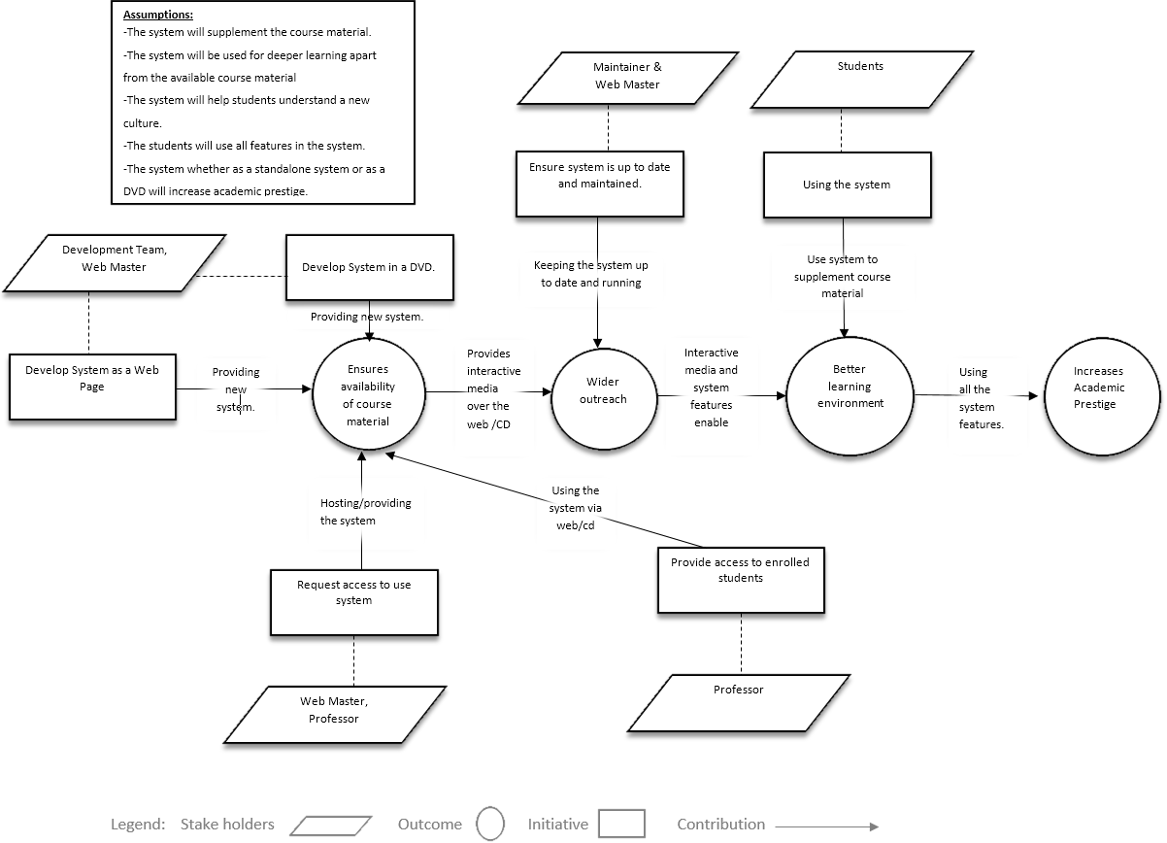**Figure 1: Benefits Chain Diagram**

#### System Boundary and Environment

The system boundary and environment diagram contains a list of services and functions that the project team will be responsible for developing and delivering, as well as the system environment showing the stakeholders' organizations and other systems for which the project has no authority or responsibility, but with which the delivered system must interface in order to deliver the desired benefits. The figure below shows the basic structure context diagram used to define the system boundary. Below is a template and an example of a system boundary and environment diagram.

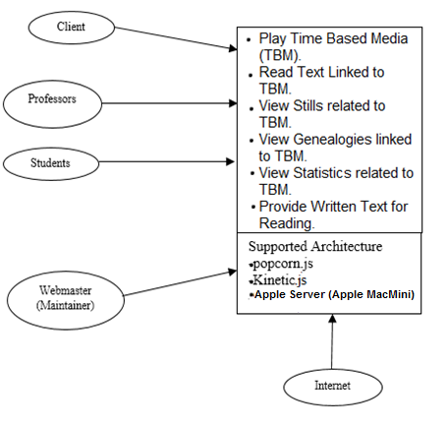

Figure 2: System Boundary and Environment Diagram

### System Transformation

#### Information on Current System

##### Infrastructure

Current Infrastructure:

* The client only has the CD-ROM along with the user manual.
* The client also possesses an old Mac machine which is capable of running the software.
* The video file is available and is being rendered at the client’s side for better quality.
* The CD-ROM was unable to run on a virtually setup Windows OS Environment, on Team’s machine.
* The client is unaware if the previous source code is available or not. Client will check and confirm.
* The client is also unaware of any documentation that may have been used for the development of current system. Client will check and confirm.
* The client is also unaware of any assets available for the system, e.g. document files, images, maps, that can be used for development.

##### Artifacts

|  |  |  |
| --- | --- | --- |
| **Artifact** | **Description** | **Requested/ Shown /Received** |
| Application Software | Software in the form of a CD-ROM. | Received |

##### Current Business Workflow

**Student**

**Professor**

Enrolls in Course and Requests Access to DVD

Provides DVD to Student

Runs Yanomamo Interactive DVD on System

Figure 3: Current Business Workflow

#### System Objectives, Constraints and Priorities

##### Capability Goals

Table 2: Capability Goals

|  |  |
| --- | --- |
| **Capability Goals** | **Priority Level** |
| OC-1: Play Time Based Media | Must Have |
| OC-2: Link Text to TBM | Must Have |
| OC-3: Link Stills to TBM | Must Have |
| OC-4: Link Statistics to TBM | Must Have |
| OC-5: Link Genealogies to TBM | Must Have |
| OC-6: Provide written text for reading. | Must Have |

##### Level of Service Goals

Table 3: Level of Service Goals

|  |  |  |
| --- | --- | --- |
| **Level of Service Goals** | **Priority Level** | **Referred WinWin Agreements** |
| **Availability:** System must be available at least 8 hours a day, preferably from 9am to 5pm. | Should Have | WC-2344 |
| **Interoperability:** System must be available to students across platforms, i.e. on the various web browsers such as Internet Explorer, Mozilla Firefox and Google Chrome. | Should Have | WC-2343 |

##### Organizational Goals

**OG-1:** Increased availability and wider outreach of Course material.

**OG-2:** A better learning environment for the students.

**OG-3:** Facilitates deeper learning and information access about the culture.

**OG-4:** Increased academic prestige.

##### Constraints

* The system should be able to run on any modern browser that supports HTML 5.

##### Relation to Current System

Table 4: Relation to Current System

|  |  |  |
| --- | --- | --- |
| **Capabilities** | **Current System** | **New System** |
| Roles and Responsibilities | The Current system did not have any roles or responsibilities. | The new system will have a webmaster that will ensure that the system is running for 8 hours daily. |
| User Interactions | The user had limited features in the current system. E.g.: No full screen capability for the video. | The user has access to the features that were not present in the current system. E.g.: Full Screen feature for the video. |
| Infrastructure | System was distributed as a DVD that worked only on old MAC systems. | System is now a web based application, which can be accessed on any platform. |
| Stakeholder Essentials and Amenities | The system is primarily used as learning material available to only some students, who have access to old MAC Systems. | The system is now capable of providing a learning environment to a large number of students that can access the system from anywhere. |
| Future Capabilities | Limited outreach and availability. | The new system can now be used to provide a wider outreach of the course material and increase availability. |

#### Proposed New Operational Concept

##### Element Relationship Diagram

Student

Yanomamo Interactive System

Professor

Webmaster/ Maintainer

Figure 4: Element Relationship Diagram of Yanomamo Interactive Online System

##### Business Workflows

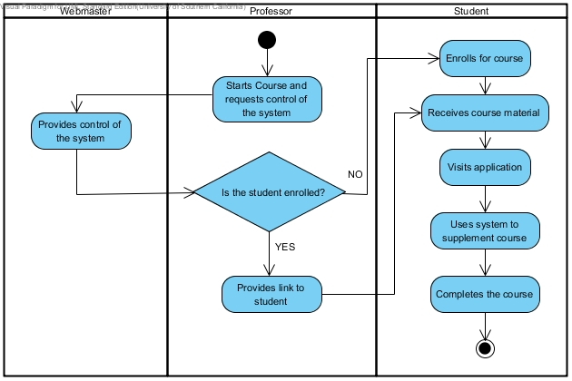Figure 5: Business Workflows Diagram

#### Organizational and Operational Implications

##### Organizational Transformations

* The elimination of the need for an old MAC system to run the software.

##### Operational Transformations

* The organization will facilitate the professors to offer the course to several students, who can access the system across various platforms.
* The system will increase academic prestige of the organization.